|  |  |
| --- | --- |
| **Ex. No : 3**  **Date:** | **Write a Servlet program that prints "Hello, World! when accessed through a browser** |

**AIM:**

To write a Java Servlet program that responds with the message **"Hello, World!"** when accessed through a web browser, demonstrating the basic structure and functionality of a servlet.

**PROGRAM:**

package com.ramesh.servlet;

import java.io.IOException;

import java.io.PrintWriter;

import javax.servlet.ServletException;

import javax.servlet.annotation.WebServlet;

import javax.servlet.http.HttpServlet;

import javax.servlet.http.HttpServletRequest;

import javax.servlet.http.HttpServletResponse;

@WebServlet("/HelloWorldServlet")

public class HelloWorldServlet extends HttpServlet {

private static final long serialVersionUID = 1L;

protected void doGet(HttpServletRequest request, HttpServletResponse response) throws ServletException, IOException {

PrintWriter pw = response.getWriter();

pw.println("HelloWorld");

}

}

231801134

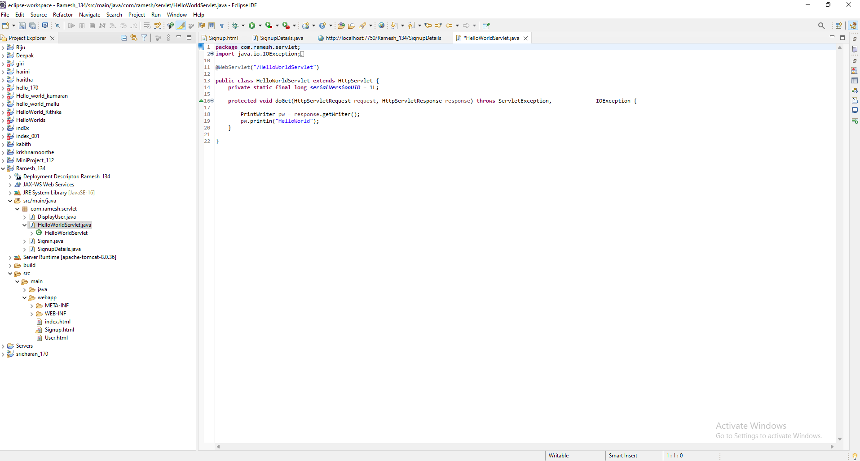

**OUTPUT:**

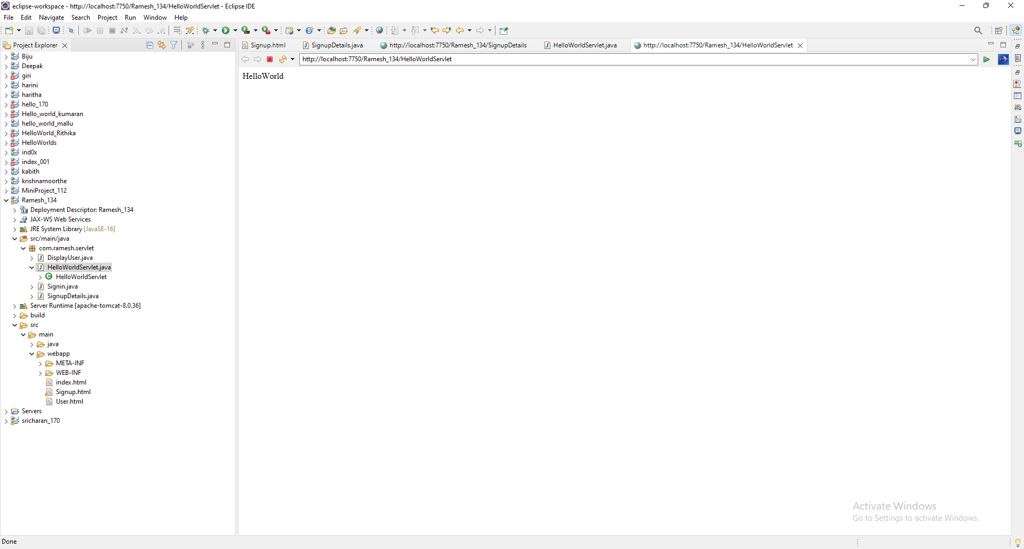

**RESULT:**

The output "Hello, World!" was successfully displayed in the browser when the servlet was accessed.

231801134